

**MOOC Based Seminar Report**

**On**

**Introduction to**

**Web Development**

BY : **Shreshth Tiwari**

ROLL NO: **1961159**

COURSE: **B.TECH**

BRANCH : **CSE**

UNDER THE GUIDANCE OF

**DR. SUDHANSHU MAURYA**

DURING THE YEAR **2020-2021**



**ACKNOWLEDGEMENT**

I would like to give a special thanks to several people who made this all possible.

It is because of their tremendous support that I was able to finish this project with immense success .

I would like to thank each and everyone who helped me in the completion of this project, but firstly and fore mostly I would like to pour my heart out in gratitude and humility towards our MOOC coordinator **Dr. Sudhanshu Maurya** who ostensibly supported me in this project whole heartedly.

I consider myself very fortunate and gratified that I was given an opportunity and once again would like to show my appreciation whole heartedly to everyone to make this possible.

shreshth.tiwari.24@gmail.com SHRESHTH TIWARI



**BHIMTAL CAMPUS**

**THIS IS TO CERTIFY THAT MR. Shreshth Tiwari HAS SATISFACTORILY PRESENTED MOOC BASED SEMINAR. THE COURSE OF THE MOOC Introduction To Web Development IN PARTIAL FULFILMENT OF THE SEMINAR PRESENTATION REQUIREMENT IN 3rd SEMESTER OF B.TECH (CSE) DEGREE COURSE PRESCRIBED BY GRAPHIC ERA HILL UNIVERSITY BHIMTAL CAMPUS DURING THE YEAR** 2020-2021**.**

MOOC–Coordinator- HOD-

Name: __________________________ Name: ___________________________________

Signature: ______________________ Signature: ______________________________



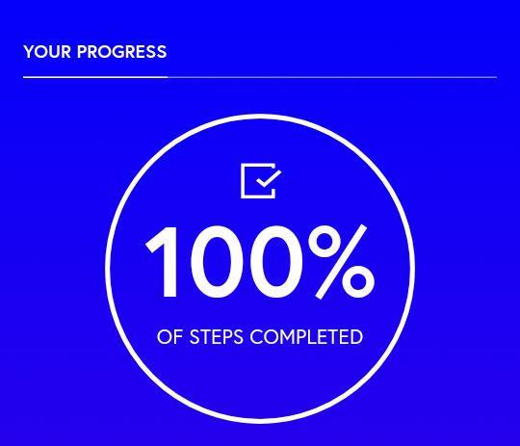**Copy Of Confirmation Of Course Completed Received**



**BHIMTAL CAMPUS**

**WEEK 1**

**(Introduction)**

**Learning Objectives-**

* Take a real-life problem and abstract out the pertinent aspects necessary to solve it.
* Formulate formal solutions to well defined problems using the logic of a programming language.

**What is a well-defined problem?**

* A well-defined problem means that
* A solution exists for the problem.
* The solution can be found in finite number of steps.
* Examples:
* 1x2+3=?

=(1X2)+3

=2+3

=5

Therefore 1X2+3=5

* 1+2x3=?

=1+(2x3)

=1+6

=7

Therefore 1+2x3=7

**Problem-**

**Is the problem statement “Finding the best way to travel from Hong Kong to London” a well-defined problem?**

*Needs Clarification on-*

* *Where exactly are the origin and destination?*
* *What does it mean by the best way?*
* *What are the modes of transportation?*

Therefore, it is not a **well-defined** problem.  
  
**There are two important components in the computer-**

* Hardware component.
* Software component.

**First Computer-**

* It was the world’s first all-purpose electronic computer, ENIAC (Electronic Numerical Integrator And Computer), was created at U. Penn in 1946.
* It weighted over 30 tons, contained ~18,000 vacuum tubes and occupied 1800ft2 (180 m2) of space.

**Moore’s Law-**

* Gordon Moore (1965): The processing power of computer chip doubles approximately every 18 months.

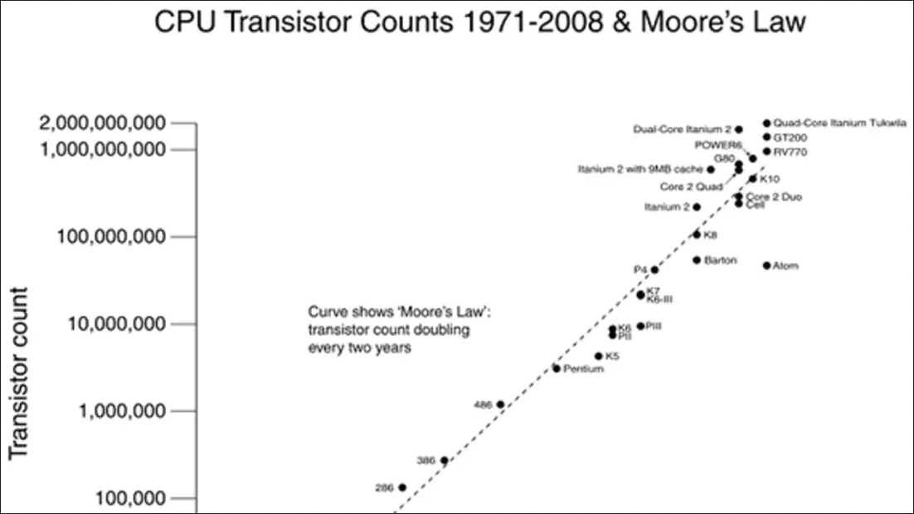

**Hardware Prospective**-

* Data flow through different hardware components-

**Input Devices**

**Processing**

**Output Devices**

**Memory**

**Storage Devices**

**Input Devices**- Microphone, Mouse, Keyboard, scanner.

**Processing**- CPU

**Memory**- RAM

**Storage Devices**- Hard Disks, Flash Drives, SD Cards.

**Output Devices**- Monitor, printer, projector, speakers.

**CPU (**Central Processing Unit**)-**

* It is the brain of the computer.
* It is generally found everywhere-

Desktops, Mobiles, I Pads, I Phones, Laptops.

* It retrieves instructions from the memory and performs computation.
* It consists of 2 sub-units-

1. **ALU**(Arithmetic Logic Unit)**-**

**-** Basic arithmetic operations +,-,*,/.

**-** Logical Comparisons =,<,>.

1. **CU-** Control Unit**-**

**-** Controlling access to the main storage.

**-** Controlling the sequence in which instructions are executed.

**-** Regulating the timing of all operations carried out within the CPU.

**-** Sending and receiving control signals to and from peripheral devices.

**-** Controlling data flow between the ALU and main memory.

**Memory-**

* **Registers-** fast memory for data that the processor is working on.
* **Main Memory-** Random Access Memory (RAM) holds the program instructions and the data for the program.
* **Cache memory-** stores frequently used data in order to reduce the access time to the main memory.

**Input Devices-**

* Obtain information from users.
* Examples-

1. Keyboard.
2. Mouse.
3. Microphone.
4. Scanner.

**Output Devices-**

* Sends information from computers to users.
* Examples-

1. Monitor.
2. Speakers.
3. Printers.
4. Projectors.
5. Plotters.

**Storage Devices-**

* Data will not disappear when the power is turned off.
* Data and programs are moved from storage devices to memory when the computer needs them.
* Examples-

1. Disk Drive. - Hard Disk, Flash memory.
2. Optical Drive- CD, DVD.

* They are slower and less efficient then the main memory.
* One recent development is cloud storage which allows a large amount of data to be stored in off-site data centers accessible through the Internet.

**Software-**

Computer hardware by itself would not be very useful.This is like after constructing a building for a library,before the books are put into the bookshelves, it would not function well as a library.One needs to provide a computer clear instructions in order for it to perform something useful.This kind of instructions can be called software.

A software is the set of instructions that are given to a computer for performing certain tasks.

**Software Hierarchy-**

**Software**

**System Software**

**Application Software**

**System Software-**

**-** Programs that support execution and development of other programs.

**-** Two major type-

1. Operating System- Windows, Linux, Unix, Ubuntu, IOS,MAC OS, Android.
2. Translation Systems (compilers and linkers)- MS Visual C++, Java, Python, C, C++.
3. Utility Programs- Antiviruses, drivers etc.

**Application Software-**

**-** Programs designed to perform specific tasks and are easy to use.

**Interface between Hardware and Software-**

Users

Application Software

System Software

Hardware

System software can interact directly with hardware.

System software can also interact directly with software.

Users have direct interaction with both application and system software. Users can also- refer to application or system programmers.

**User Interface-**

* In general, a user interface is the interaction between a user and a computer.
* A part of an OS is dedicated to provide User Interface between the OS and the User.

**-** Example- The OS provides an interface for the user to manipulate the File System.

* Two types of User Interfaces-

1. **Command Line Interface-**

**-** The user types in keywords that are instructions to the OS.

**-** Example- Command Prompt in PC systems.

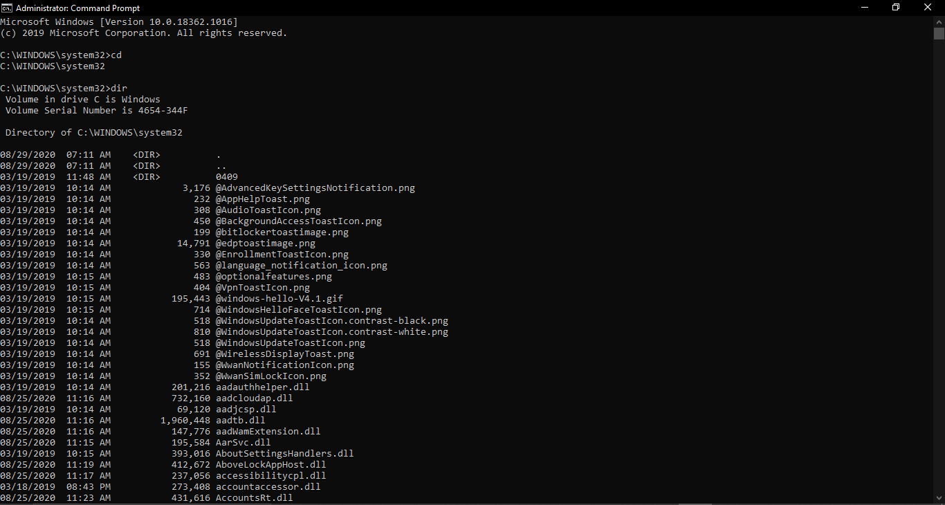

1. **Graphical User Interface-**

**-**  In a graphical User Interface, the computer screen displays graphical objects such as icons, menus and windows.

**-** The user has a pointing device to activate functions related to the objects.

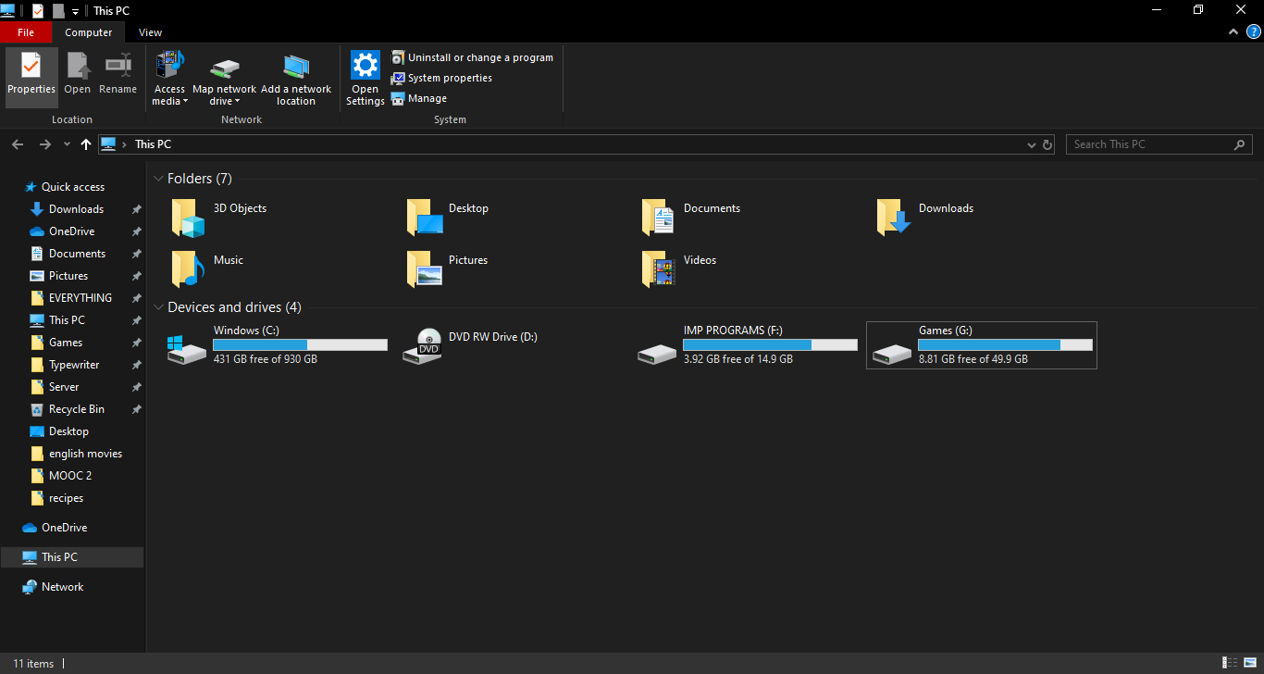

**Problem Solving process**-

* Define and analyze the problem.
* Develop a solution.
* Write down the solution steps in detail.
* Test and evaluate the solution, revise if necessary.
* Document and maintain the solution.



**WEEK 2**

**(Basics)**

**What comprises a website?**

**Components of a website-**HTML (Hyper Text Markup Language)

Images

**Viewed from a web browser like-**

**Safari-** Common on Apple.

**Chrome-** From Google.

**Microsoft Edge-** From Microsoft.

**Firefox-** From the Mozilla Foundation

**Structure of a Website-**

Home Page

Main Sections

Subsections

(Index Page)

Site Index

Content

**Types of files viewed through web browser-**

HTML (Hyper Text Markup Language).

CSS (Cascading Style Sheets).

JS (Java Script).

Images, picture, arts and graphic.



**WEEK 3**

**(HTML)**

First developed by Tim Berners-Lee in 1990, **HTML** is short for **Hypertext Markup Language**. HTML is used to create electronic documents (called pages) that are displayed on the World Wide Web. Each page contains a series of connections to other pages called hyperlinks. Every web page you see on the Internet is written using one version of HTML code or another.

HTML code ensures the proper formatting of text and images for your Internet browser. Without HTML, a browser would not know how to display text as elements or load images or other elements. HTML also provides a basic structure of the page, upon which Cascading Style Sheets are overlaid to change its appearance. One could think of HTML as the bones (structure) of a web page, and CSS as its skin (appearance).

## What does an HTML tag look like?

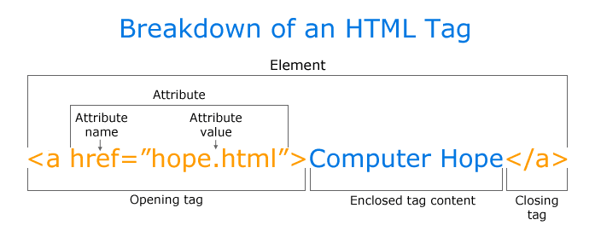

In an HTML tag, there aren't many components. Most HTML tags have an opening tag containing the tag name, tag attributes, a closing tag containing a forward slash, and the tag name being closed. For tags that do not have a closing tag like <img>, it is best practice to end the tag with a forward slash.

Most tags are contained in a less than and greater than angle brackets, and everything between the open and close tag is displayed or affected by the tag. In the example above, the <a> tag is creating a link called "Computer Hope" that is pointing to the hope.html file.

## What does HTML look like?

Below is an example of a basic web page written in HTML with a description of each section and its function.

<!DOCTYPE HTML PUBLIC "-//SHT//DTD HTML 4.01 Transitional//EN" "https://www.sht.org/TR/html4/loose.dtd">

<html>

<head>

<title>Example page</title>

<meta http-equiv="Content-Type" content="text/html; charset=windows-1252">

</head>

<body>

<h1>This is a heading</h1>

<p>This is an <b>example</b> of a basic HTML page.</p>

</body>  
</html>

he box above contains the key ingredients to a basic web page. Each of the lines are explained below in further detail.

1. The DOCTYPE line describes what version of HTML the page was written in so that an Internet browser can interpret the text that follows.
2. The <html> opening tag lets the browser know that it is reading HTML code.
3. The <head> section contains information about the page, such as its title, meta tags, and where to locate the CSS file.
4. The <body> section contains everything that's viewable on the browser. For example, all the text seen here is contained in the body tags.
5. The <h1> tag is the visible heading of the page.
6. The <p> tag is a paragraph of text. Most web pages (like this one) have several paragraph tags.
7. Contained in the paragraph is the <b> tag that bolds the word example in the paragraph.
8. Finally, the closing tags wrap each of the above tags.

## What is HTML5?

**HTML5** is the update made to HTML from HTML4 (XHTML follows a different version numbering scheme). It uses the same basic rules as HTML4, but adds some new tags and attributes which allow for better semantics and for dynamic elements that are activated using JavaScript. New elements include: <article>, <aside>, <audio>, <bdi>, <canvas>, <datalist>, <details>, <embed>, <figure>, <figcaption>, <footer>, <header>, <keygen>, <mark>, <meter>, <nav>, <output>, <progress>, <rp>, <rt>, <ruby>, <time>, <track>, <video>, and <wbr>. There are also new input types for forms, which include tel, search, url, e-mail, datetime, date, month, week, time, datetime-local, number, range, and color.

With the increasing movement to keep structure and style separate, some styling elements were removed, along with those that had accessibility issues or saw very little use. These following elements should no longer be used in HTML code: <acronym>, <applet>, <basefont>, <big>, <center>, <dir>, <font>, <frame>, <frameset>, <noframes>, <strike>, and <tt>. HTML5 also simplifies the doctype declaration to the tag in the following box.

<!doctype html>

## What does HTML5 look like?

<!doctype html>

<html>

<head>

<meta charset="utf-8">

<title>Example page</title>

</head>

<body>

<h1>This is a heading</h1>

<p>This is an example of a basic HTML page.</p>

</body>

</html>

## How to create and view HTML

Because HTML is a markup language, it can be created and viewed in any [text editor](https://www.computerhope.com/jargon/e/editor.htm) if saved with a *.htm* or *.html* [file extension](https://www.computerhope.com/jargon/f/fileext.htm). However, most find it easier to design and create web pages in HTML using an [HTML editor](https://www.computerhope.com/htmldown.htm).

Once the HTML file is created, it can be viewed locally or [uploaded](https://www.computerhope.com/jargon/u/upload.htm) to a [web server](https://www.computerhope.com/jargon/w/webserve.htm) to be viewed online using a [browser](https://www.computerhope.com/jargon/b/browser.htm).

## Which file extensions are used with HTML?

HTML files use either the .htm or .html [file extension](https://www.computerhope.com/jargon/f/fileext.htm). Older versions of Windows (Windows 3.x) only allow three-letter file extensions, so they used .htm instead of .html. However, both file extensions have the same meaning, and either may be used today. That being said, we recommend sticking to one naming convention as certain web servers may prefer one extension over the other.



**WEEK 4**

**(JavaScript)**

**The value of JavaScript**

HTML alone is static, even if we use images, CSS and lots of creativity, still it is static.

**How do we make pages responsive?**

We want our website to be responsive:

When a user takes an action.

We want to respond with action.

We can’t do that with plain text HTML.

**HTML is NOT a programming language**

It is a markup language.

It uses tags.

**What can a programming language do that HTML can’t?**

Take steps and actions in a sequence.

Do things repetitively in a loop.

Make decisions based on the data.

**JavaScript is a Programming Language**

Gives us ability to make interactive pages.

Gives us ability to interact with:

Users.

Visitors.

## Client-Side JavaScript

Client-side JavaScript is the most common form of the language. The script should be included in or referenced by an HTML document for the code to be interpreted by the browser.

It means that a web page need not be a static HTML, but can include programs that interact with the user, control the browser, and dynamically create HTML content.

The JavaScript client-side mechanism provides many advantages over traditional CGI server-side scripts. For example, you might use JavaScript to check if the user has entered a valid e-mail address in a form field.

The JavaScript code is executed when the user submits the form, and only if all the entries are valid, they would be submitted to the Web Server.

JavaScript can be used to trap user-initiated events such as button clicks, link navigation, and other actions that the user initiates explicitly or implicitly.

## Advantages of JavaScript

The merits of using JavaScript are −

**Less server interaction** − You can validate user input before sending the page off to the server. This saves server traffic, which means less load on your server.

**Immediate feedback to the visitors** − They don't have to wait for a page reload to see if they have forgotten to enter something.

**Increased interactivity** − You can create interfaces that react when the user hovers over them with a mouse or activates them via the keyboard.

**Richer interfaces** − You can use JavaScript to include such items as drag-and-drop components and sliders to give a Rich Interface to your site visitors.

## Limitations of JavaScript

We cannot treat JavaScript as a full-fledged programming language. It lacks the following important features −  
Client-side JavaScript does not allow the reading or writing of files. This has been kept for security reason.

JavaScript cannot be used for networking applications because there is no such support available.

JavaScript doesn't have any multi-threading or multiprocessor capabilities.

Once again, JavaScript is a lightweight, interpreted programming language that allows you to build interactivity into otherwise static HTML pages.

## JavaScript Development Tools

One of major strengths of JavaScript is that it does not require expensive development tools. You can start with a simple text editor such as Notepad. Since it is an interpreted language inside the context of a web browser, you don't even need to buy a compiler.

To make our life simpler, various vendors have come up with very nice JavaScript editing tools. Some of them are listed here −

**Microsoft FrontPage** − Microsoft has developed a popular HTML editor called FrontPage. FrontPage also provides web developers with a number of JavaScript tools to assist in the creation of interactive websites.

**Macromedia Dreamweaver MX** − Macromedia Dreamweaver MX is a very popular HTML and JavaScript editor in the professional web development crowd. It provides several handy prebuilt JavaScript components, integrates well with databases, and conforms to new standards such as XHTML and XML.

**Macromedia HomeSite 5** − HomeSite 5 is a well-liked HTML and JavaScript editor from Macromedia that can be used to manage personal websites effectively.

## Where is JavaScript Today ?

The ECMAScript Edition 5 standard will be the first update to be released in over four years. JavaScript 2.0 conforms to Edition 5 of the ECMAScript standard, and the difference between the two is extremely minor.

Today, Netscape's JavaScript and Microsoft's JScript conform to the ECMAScript standard, although both the languages still support the features that are not a part of the standard.



**WEEK 5**

**(CSS)**

## What is CSS?

* **CSS** stands for **C**ascading **S**tyle **S**heets
* CSS describes **how HTML elements are to be displayed on screen, paper, or in other media**
* CSS **saves a lot of work**. It can control the layout of multiple web pages all at once
* External stylesheets are stored in **CSS files**

## CSS Demo - One HTML Page - Multiple Styles!

Here we will show one HTML page displayed with four different stylesheets. Click on the "Stylesheet 1", "Stylesheet 2", "Stylesheet 3", "Stylesheet 4" links below to see the different styles:

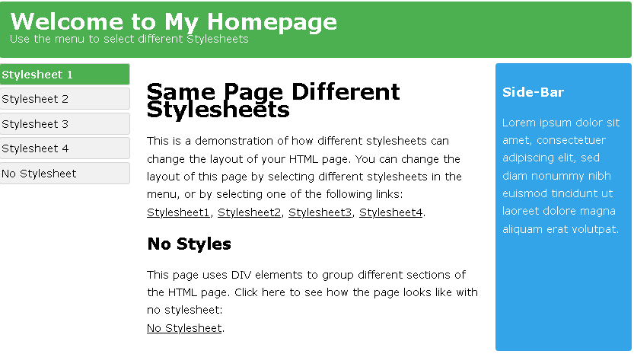

## Why Use CSS?

CSS is used to define styles for your web pages, including the design, layout and variations in display for different devices and screen sizes.

### CSS Example

body {  
  background-color: lightblue;  
}  
  
h1 {  
  color: white;  
  text-align: center;  
}  
  
p {  
  font-family: verdana;  
  font-size: 20px;  
}

## CSS Solved a Big Problem

HTML was NEVER intended to contain tags for formatting a web page!

HTML was created to **describe the content** of a web page, like:

<h1>This is a heading</h1>

<p>This is a paragraph.</p>

When tags like <font>, and color attributes were added to the HTML 3.2 specification, it started a nightmare for web developers. Development of large websites, where fonts and color information were added to every single page, became a long and expensive process.

To solve this problem, the World Wide Web Consortium (W3C) created CSS.

CSS removed the style formatting from the HTML page!

## CSS Saves a Lot of Work!

The style definitions are normally saved in external .css files.

With an external stylesheet file, you can change the look of an entire website by changing just one file!